O R I O N GROUP H I S T O R Y

A History of the Group is as follows

1 9 8 2

Before Orion June 1982 To Janaury 1984

June Joe Beedell goes to his local paper the" Evening Echo" about starting a T.V. S.F.Club, The story hits the paper with the headline "Joseph Calling All SF Fans" He gets 40 phone calls over six hours and a group first have a meeting on June 27th

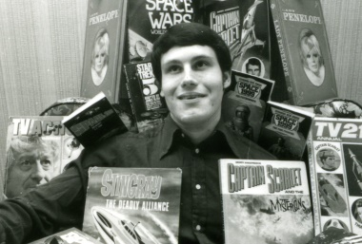

Copyright Newsquest/Evening Echo1982
Photo Above Joe Beedell the founder of Fandom in Southend 40 years ago

Jul The group attend the 1st showing of Star Trek II The Wrath Of Khan In costumes made by themselves.

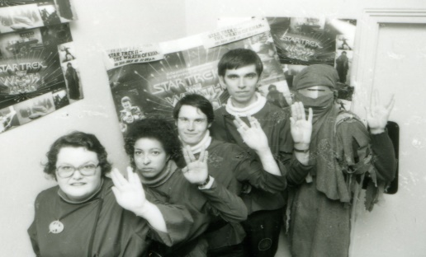

Photo Above Left to right Joy Lenoard Sharon Davids Joe Beedell Phillip Birch Danny Cohen

Aug Plans are made to hold a large meeting at Southend Library, We attend a book singing at Terrys Bookshop Sept A Public meeting is held at Southend Library in the lecture Room its advertised on Essex Radio,Sefact,Evening Echo,plus by posters around town the meeting is a large success for the group

Oct We attend our 1st Westminster comic convention the next day the group start to have weekly meetings plus later in that month we put a video together which is still in existence to-day but is kept under wraps!

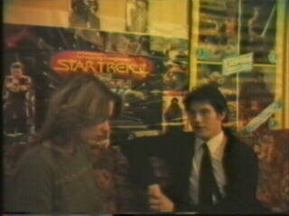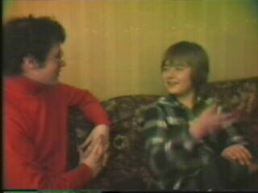 1
Page 2

SF IN ESSEX THE VIDEO
Copyright 1982
Dot Parkinson Interviewing Joe Beedell, Sharon David’s And Joe Beedell with Mark Birch

Dec We have a small party the first of many as it would turn out!

1 9 8 3

Jan The club has an open evening at Southend Library
Mar Plans are made to put a fanzine out in June Editors Joe Beedell & Chris Deakins the fanzine is called EMINAR

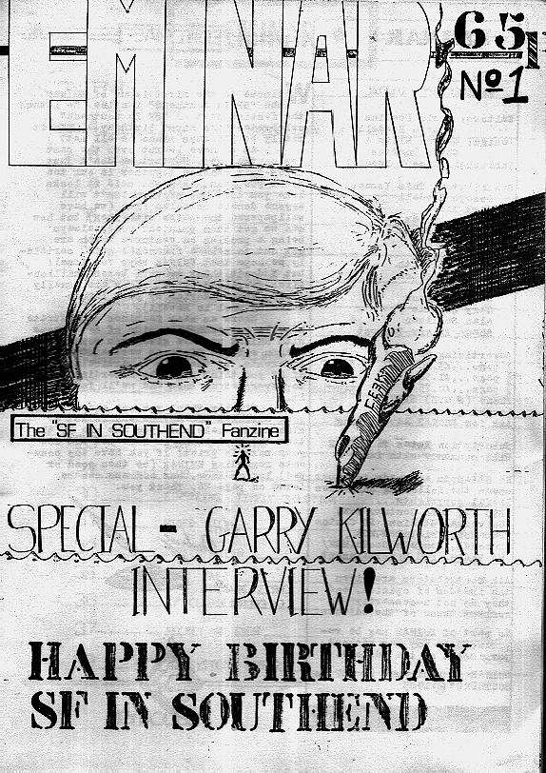
Artwork Cover by Warren Ellis
Page 3

May A New SF Bookshop Perilous Dreams opens in Southend
Jun Our fanzine Eminar is out to day at a page count of 40 pages 70 issues are printed all together, we go to Southchurch Park and have a sales table. Our 1st Birthday party started 5pm and ended 2am all went well!,

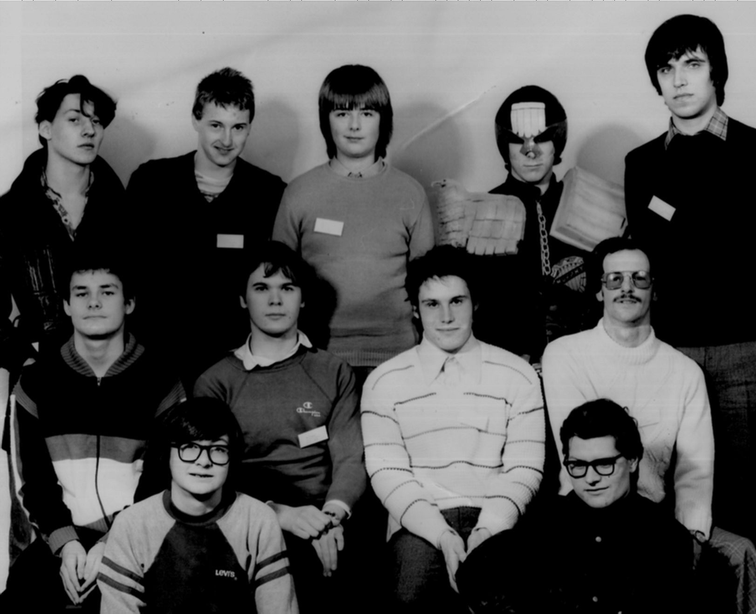

Photo June 1983 Top Row S.Biggs,G,Storie,M.Birch,J.Murphy,P.Birch
Middle Row J.Goldsmith,Chris Deakins,J,Beedell, J.Bishop D.Marks.

June 28th Tuesday 7.00pm The Cork And Cheese pub...The 1st Meeting of The Alternative SF Group takes place,
Joe Beedell goes along to meet Dave Harwood & Ashley Watkins the founders
July The Beccon Convention members of both groups go along and have a good time!
Sept It is decided that the name of the 1st group is to be changed to SF In Southend
Oct Chris Deakins starts work on the second fanzine name to be decided Rod Serling's The Twilight Zone begins showing on BBC2 from the 1959 1st Season
Nov Sky TV starts Broadcasting
Dec Mark Birch tells Joe Beedell that a new name and new direction might be just what the 1st group needs (the Name ORION is picked)

1 9 8 4
Jan Work starts on the new format for the new club ORION it will cater for fans of the following TV shows: Twilight Zone, Outer Limits, Night Gallery, Voyage To The Bottom Of The Sea, Lost In Space-Time Tunnel, Land of the Giants,

“I Know we had our critics and I & My Co Directors had to pull out all the stops to make things right and I was shocked at what we able to do as a group in the United Kingdom because we did stand out as something that had not been done before…..”Joe Beedell
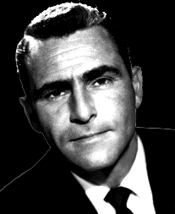 Rod Serling 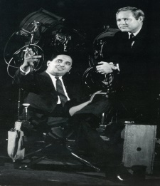 Joe Stefano & Leslie Stevens
Page 4
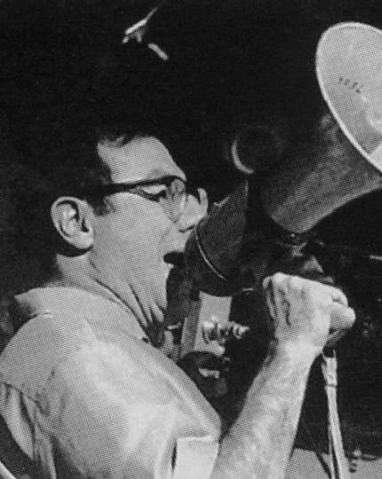 Irwin Allen

Somewhere Sometime On This Planet Someone In Front Of A Television Set Will Be Enjoying The Work Of These Men And The Talent Working With Them For They Have Fullfilled Their Comittment To Entertain & Inspire Us Their Audience.
Their Work Will Continue To Entertain Many Generations To Come,They Will Be Much Missed By All They Entertain And Their Work Will Continue To Touch

Someones Life And Enrich It.

“ No one in the United Kingdom had at that time ever ran a fan club for the shows that ORION covered” Joe Beedell Dec 1983 we found a gap in the market…..we were in the dark and there was not a lot of information about at that time apart from VHS copies of the shows so we took it from there…….

Feb The Co Directors are as follows: Joe Beedell,Sharon Davids,Mark Birch,Chris Deakins. Apr Orion’s 1st N/L is released, Joe meets Richard Holliss at Forbidden Planet 2 in London and tells him all about the club, and Richard tells Joe that he will plug the club in a soon to be issued magazine Starburst in his TV Zone page.

May ORION FANZINE No 1 is released, Joe and Chris are Co-Editors

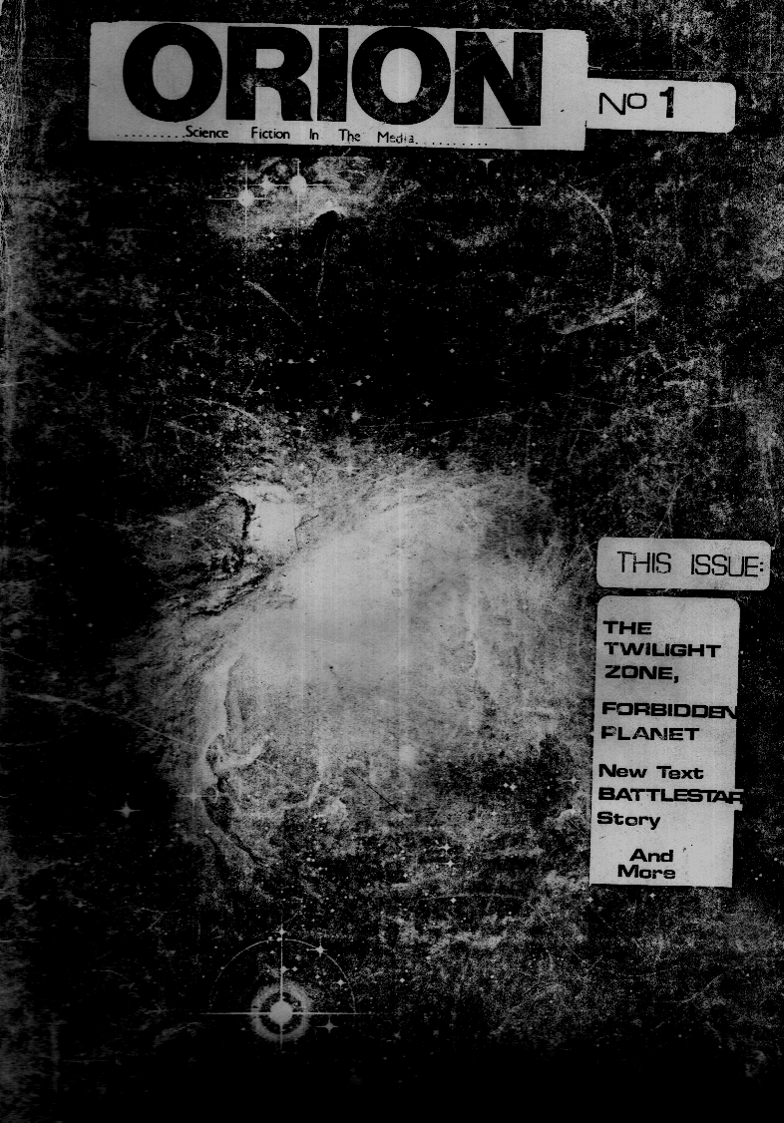

Jun Orion 2nd N/L is sent out, The Alternative SF Group 1 year old Jul Chris Deakins starts work on Orion Fanzine No 2 Aug Starburst No 72 is out with the plug for Orion (See Article)over the following two months we get loads of letters asking for details of membership!,V starts showing on ITV Sept Orion’s 3rd N/L is sent out,

Page 5

Orion Fanzine No 2 Is done and sent out with a new cover by Paul Duncan and new logo by Sean O Sullivan

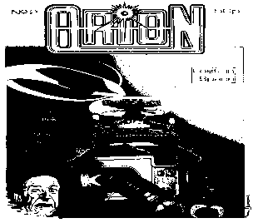

Oct Work starts on our 4th newsletter which will have Voyage fiction by Joan Hobbs.Dec ORIONS 3rd Xmas party

1 9 8 5

Jan Alan Sullivan becomes a co-director of the club, Orion has an open day at Coalman St Day Centre, Orion N/L 4 sent out.

Feb Orion Fanzine No 3 is completed and sent out.

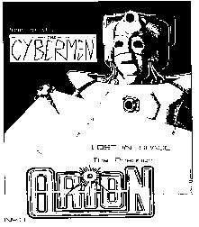

Apr Orion N/L 5 is sent out.

Jun Orion Fanzine No 4 completed
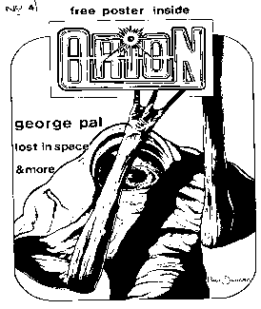

Page 6

Aug Orion No5 Fanzine completed

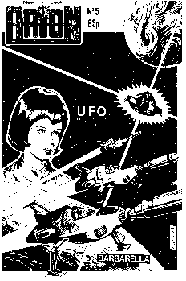

, A letter writing campaign is started to get our shows back on British TV , The Alternative SF Group 2 years old.Jul Orion N/L 6 completed, Orion has it's 1st mini convention over 20 fans attend from all over the U.K. Aug News is received from the U.S.A. that CBS have plans to start a new TZ series Sept Lost in Space starts showing on Sky T.V. from the second season colour episodes, Orion N/L 7 completed, Work starts on Fanzine No 6.Oct Channel 4 buys the rights to 52 episodes of Rod Serling's The Twilight Zone to be shown during 1986, Carol Serling joins us as a Hon Member.Nov Orion N/L 8 completed.Dec Orion Party.

1 9 8 6

Jan Orion N/L 9 Completed.

Feb Orion Fanzine No 6 Completed.
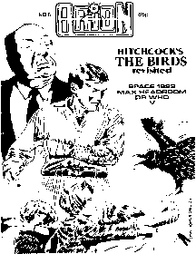

Mar Orion N/L 10 completed.

Jun the Alternative SF Group 3 years old & Rod Serlings Night Gallery Pilot is shown on Anglia TV

Page 7

Jul Work starts on Orion Fanzine No 7.

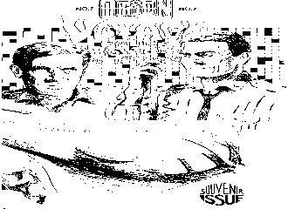

Aug Land Of The Giants Starts showing on Sky TV.Sep Plans are made to have an ORICON 87.Oct Orion N/L 11 Completed.Dec Orion Party.

1 9 8 7

Jan Orion N/L 12 Completed. Feb the Time Tunnel Starts showing on Sky TV.
Mar Orion N/L 13 Completed, Channel 4 Buy all 83 Episodes of Lost In Space for showing from Oct 88 also they get a option to buy all the Irwin Allen Series Jun Orion 3 years old, The Alternative SF Group 4 years old Sep Orion N/L 14 Completed. Oct 5-7th Miracle Con Takes place with Joe Beedell on the committee. Dec Orion Party.
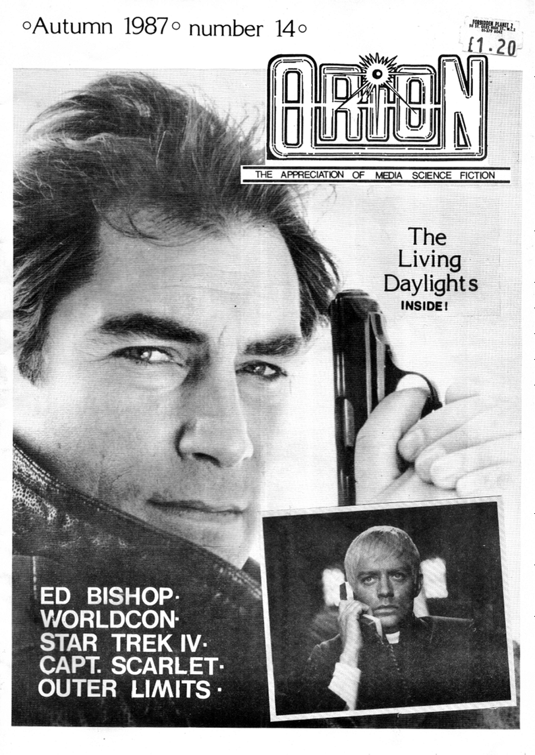

1 9 8 8

Mar Lost in Space starts to air on Channel 4 its 1st showing on network television since 1965
Apr Orion N/L 15 completed.
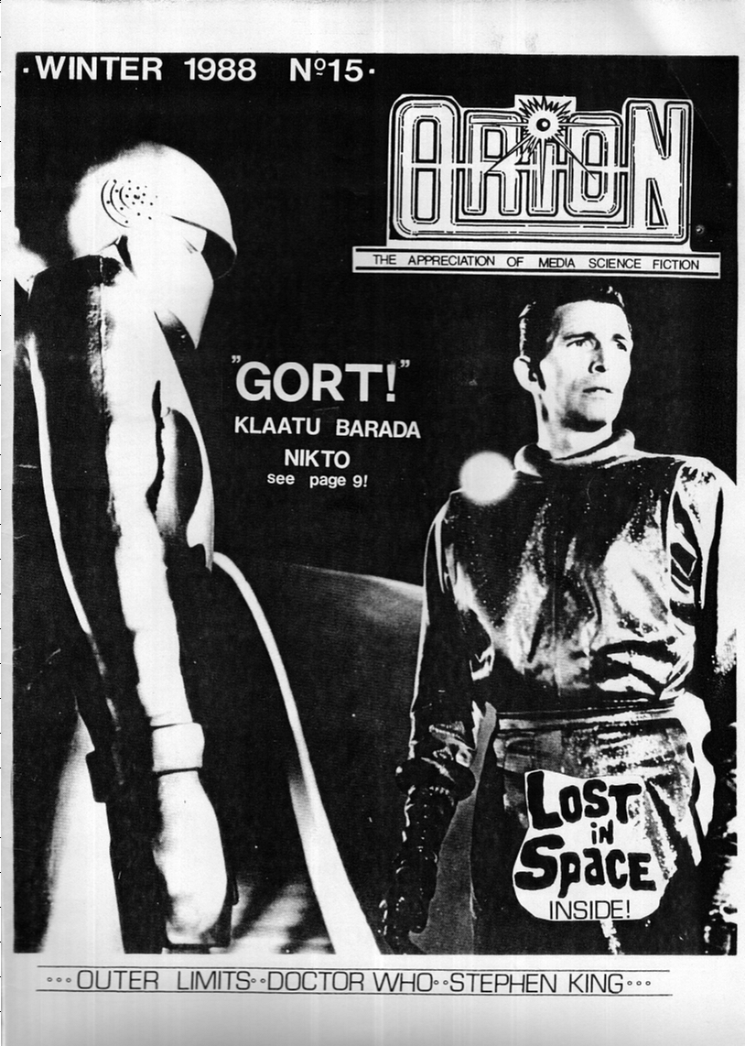

Jul Twilight Zone on Channel 4 Aug The Invaders Re-airs on BBC 2.
Sep Orion N/L 16 completed

Oct Midcon 88

Page 8

1 9 8 9

Jan Twilight Zone 5th season on Channel 4 & Lost In Space Getting 3.5 million Viewers in the 1pm Sunday Time slot Feb Sky is on the Astra satellite with 4 channels Sky 1, Sky News, Sky Movies, Eurosport, Aug TIME TUNNEL starts on Late Night Late on TVS Oct STAR TREK V Film, The New Twilight Zone Starts to air on ITV late nights Midcon 89, Night Gallery is shown in some ITV regions
1 9 9 0

Jan Sky Lost in Space's 3rd Rescreening Mon to Fri 5pm Feb Spindrift Land of The Giants Society Starts Up Mar Giants Log Starts up Apr British Satellite Broadcasting show OUTER LIMITS UNCUT Oct Midcon 90 BSkyB Merger.

1 9 9 1

Jonathan Harris Comes To London On The 13th Sept LOST IN SPACE ON VIDEO LOST IN SPACE COMIC Goes on sale with a circulation of over 60.000 Time Tunnel on Channel 4 6pm Thursdays Midcon 91 Voyage To The Bottom Of The Sea On Channel 4 From Season 1

1 9 9 2
Orion 10th anniversary meeting

Voyage To The Bottom Of The Sea is moved to the 10.45 am slot The Sea view crew starts up The Astral Traveller starts up Voyage To the Bottom of the Sea finishes it to be replaced by Land of the Giants starting in J Jan 93 Midcon 92

1 9 9 3

Land of the Giants 2nd showing on Channel 4 Outer Limits on Sky One Star Trek TNG 4, 5, 6, seasons on Sky One The Flash on Sky One The Twilight Zone on Bravo for a 132 episode run from Oct 4th 93
20th Anniversary Star Trek Con Midcon 93

1 9 9 4

Voyage 94 convention
The first Voyage three day event

Page 9

1995

South Trek 95 700 attend

1997

Voyage 97

South Trek 97 held on Southend Pier over three days 3500 fans attend

1998

Voyage in Person

Lost In Space from New Line Cinema

2002

Orion’s 20th Anniversary

2500 meetings of the local group have now taken place since 1982

this includes the fannish alternative group meeting as well to that date

2004

Orion Party

2005

Orion Party

2008

Orion Party in Kings Lynn

2011

The Irwin Allen shows on DVD

Joseph Beedell moves out of Southend-On-sea in March to County Durham

2012

Orion’s 30th Anniversary meeting is held in Southend

2015

All the series are all on DVD and Blu Rays are coming out now

50th Anniversary of Lost in Space

Page 10

2016

Gerry and Sylvia Anderson’s 1st live action tv show UFO now on Network Blu ray Joseph Beedell provides an extra interview with Ed Bishop 1st pressing sold out sales very good over 500 reviews give the thumbs up for this set and it’s been a best seller still seven years later

2019

Plans for Orion’s 40th Anniversary

Opening of the website www.orion@40.com

2022

Joseph Beedell returns to Southend On Sea from 21st-26th June for 1 week to celebrate the 40th Anniversary of the Orion Group 1 st meeting and his 60th birthday celebrations part 1 down South part 2 is up North in Aug

For more information

www.orion@40.com

